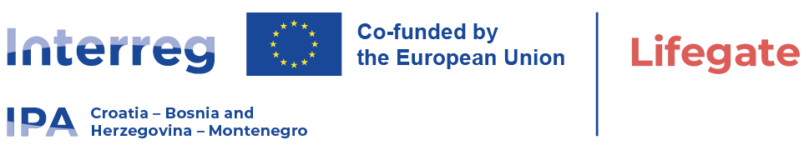

Local Open Tender Procedure within project LIFEGATE
Date: August 04. 2026.

Publication reference: 01-11-6882/26
Contract title: The Procurement of Modern Ultrasound System for Cardiovascular Diagnostic

University Clinical Hospital Mostar is announcing a call for a Local Open Tender Procedure for " The Procurement of Modern Ultrasound System for Cardiovascular Diagnostic " within the project "LIFEGATE", HR-BA-ME00489 which is Co-funded by the Interreg VI-A IPA Programme Croatia - Bosnia and Herzegovina - Montenegro 2021-2027.
The supply contract notice and tender dossier are availble from:
- University ClinicalHospital Mostar website: https://www.skbm.ba/javne-nabave/

- https://interreg-hr-ba-me.eu/project/procurements-tenders/

Tender dossier is available at link: https://www.skbm.ba/wp-content/uploads/2026/08/Tender-dossier.zip
The deadline for submission of tenders is: September, 09. 2026 at 10:00 local time.

Supply Contract Notice will be published in the Official Gazette of Bosnia and Herzegovina - Announcements Section on 07.08.2026. http://www.sluzbenilist.ba/Oglasi/index/bih

