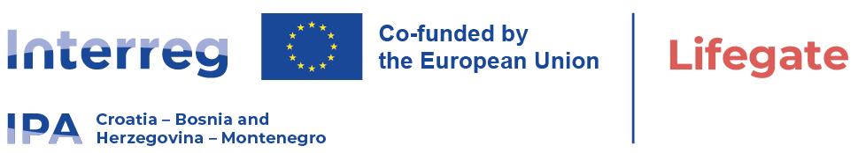

International Open TenderwithinprojectLIFEGATE
Date: February, 09. 2026.

Publication reference: 01-11-1142/2026
Contract title: Procurement of sophisticated medical equipment - stereotactic linear accelerator – LINAC
University Clinical Hospital Mostar is announcing a call for a International Open Tender procedure for "Procurement of sophisticated medical equipment - stereotactic linear accelerator – LINAC" within the project "LIFEGATE", HR-BA-ME00489 which is Co-fundedby the Interreg VI-A IPA Programme Croatia - Bosnia and Herzegovina - Montenegro 2021-2027.
Thesupplycontractnoticeand tender dossier are availblefrom:
- University ClinicalHospital Mostar website:https://www.skbm.ba/javne-nabave/
- EU tenders, Ted- tenders electronic daily:https://ted.europa.eu/en/notice/-/detail/97740-2026
TED Noticepublicationnumber: 97740-2026
Publication date: 11.02.2026
Latest version of the notice: https://ted.europa.eu/en/notice/-/detail/101461-2026
Publication date: 12.02.2026

- https://interreg-hr-ba-me.eu/project/procurements-tenders/
- University Hospital Centre Zagreb: https://www.kbc-zagreb.hr/
- ClinicalCenterofMontenegro: https://www.kccg.me/
- University Hospitalof Split: https://www.kbsplit.hr/en
- Public Health Institute ofthe Republika Srpska: https://www.phi.rs.ba/
- Institute for Public Health, Podgorica: https://www.ijzcg.me/
- Facultyof Medicine, Banjaluka: https://med.unibl.org/

Tender dossierisavailable at link: https://www.skbm.ba/wp-content/uploads/2026/02/Tender-dossier-LINAC-II.zip
Thedeadline for submissionoftendersis: April, 13. 2026 at 10:00 local time.

